Toby Chappell

CPSC 250

September 16, 2019

Homework 1

Computer Abstractions and Technology

1. What, in general terms, is the distinction between computer organization and computer architecture? (5 pts)

Computer organization: Focused on the structure and behavior of a computer system as seen by the user. Deals with low-level design issues involving physical components (circuit design, adders, signals, peripherals, etc.).

Computer architecture: Concerned with the way that the hardware components are connected together to form a system, acting as an interface between hardware and software. Deals with high-level design issues involving logic (instruction sets, addressing modes, data types, cache optimization, etc.).

1. List and briefly define the main structural components of a computer. (5 pts)

Processor (CPU): Logic circuitry that processes the basic instructions that drive the computer. Includes the ALU (which handles arithmetic and logical operations), control unit (which controls actions of other components so that instructions are performed at the appropriate time), and registers (temporary storage within the CPU).

Memory: Broken down into main memory and secondary storage. Main memory is used t store information for immediate access by the CPU. Secondary storage provides permanent storage for large amounts of data.

I/O controllers: Includes user-interface devices (display, keyboard, mouse), storage devices (hard disk, CD/DVD, flash drive), and network adapters (allows for communication with other computers).

Busses: Allow for the flow of data between different components of the computer or between multiple computers. The three types include: address bus, data bus, and a control bus.

1. A benchmark program is run on a 40 MHz processor. The executed program consists of 100,000 instruction executions, with the following instruction mix and clock cycle count: (4 pts)

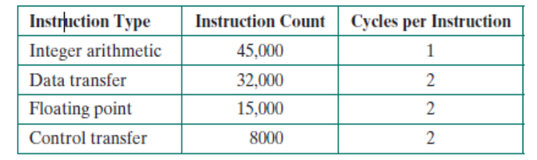

Determine the effective CPI, MIPS rate, and execution time for this program. (6 pts)

CPI: 1\*(45,000/100,000) + 2\*(32,000/100,000) + 2\*(15,000/100,000) + 2\*(8,000/100,000) = 1.55 cycles/instruction

MIPS: 40,000,000/(1.55\*10^6) = 25.8 millions of instructions/second

Execution Time:100,000\*1.55/40,000,000 = 0.003875 s = 3.875 ms

1. Early examples of CISC and RISC design are the VAX 11/780 and the IBM RS/6000, respectively. Using a typical benchmark program, the following machine characteristics result: (6 pts)

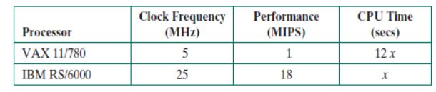

The final column shows that the VAX required 12 times longer than the IBM measured in CPU time.

1. What is the relative size of the instruction count of the machine code for this benchmark program running on the two machines?

VAX 11/780: 12,000,000x

IBM RS/6000: 18,000,000x

IBM RS/6000 has an instruction count 1.5 times larger than VAX 11/780

1. What are the CPI values for the two machines?

VAX 11/780: (12x \* 5,000,000)/(12x \* 1,000,000) = 5

IBM RS/6000: (x \* 25,000,000)/(x \* 18,000,000) = 1.3889

1. Explain Moore’s Law. (3 pts)

The number of transistors in an integrated circuit doubles every 18 months.

1. What are the SPEC benchmarks? (3 pts)

Programs used to measure the performance of a CPU. The SPEC CPU2006 consists of 2 components: CINT2006 which handles integer testing and CFP2006 for floating point testing. Play a crucial role in making the common case fast.

1. List and briefly define some of the techniques used in contemporary processors to increase speed. (6 pts)

Pipelining: Multiple instructions are overlapped in execution so that when one instruction completes the next can begin immediately.

Parallelism: Multiple processes are run simultaneously (application could be taking a large problem and breaking it into small pieces so that they can be run at the same time).

Multiprocessors: Increase the number of processors per chip. Requires explicit parallel programming.

1. Briefly characterize Amdahl’s law. (3 pts)

Formula that predicts the overall improvement to performance by improving an aspect of a computer.